BRACT’s
Vishwakarma Institute of Technology, Pune
Practical Implementation Sheet
Department: CSE-AI Semester: 5 Academic Year: 2026-27
Division: E Batch: 1 Practical No: 4
Roll no: 42 PRN No: 12414728 Name of Student: Saachi Laturiya
Subject Name : Deep Learning

Problem Statement : Develop an LSTM-based model for time-series forecasting using a sales dataset and evaluate its performance using appropriate evaluation metrics.
Algorithm :
- Import the required libraries for data processing, visualization, and deep learning.
- Generate a monthly sales dataset containing trend, seasonal variation, and random noise.
- Normalize the sales data using MinMaxScaler.
- Split the dataset into training and testing sets.
- Create sequences of 12 consecutive months to predict the next month's sales.
- Build an LSTM model with 50 units, a dropout layer, and a dense output layer.
- Compile the model using the Adam optimizer and mean squared error loss.
- Train the model for 30 epochs using the training dataset.
- Predict sales values for the test dataset and convert them back to the original scale.
- Evaluate the model using MAE, RMSE, and MAPE.
- Plot actual versus predicted sales and visualize training and validation loss.
Code :
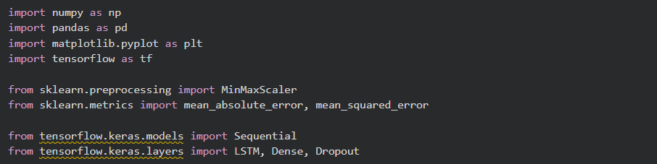
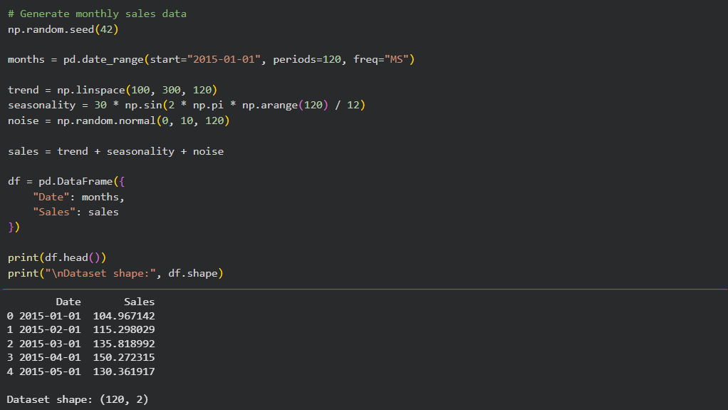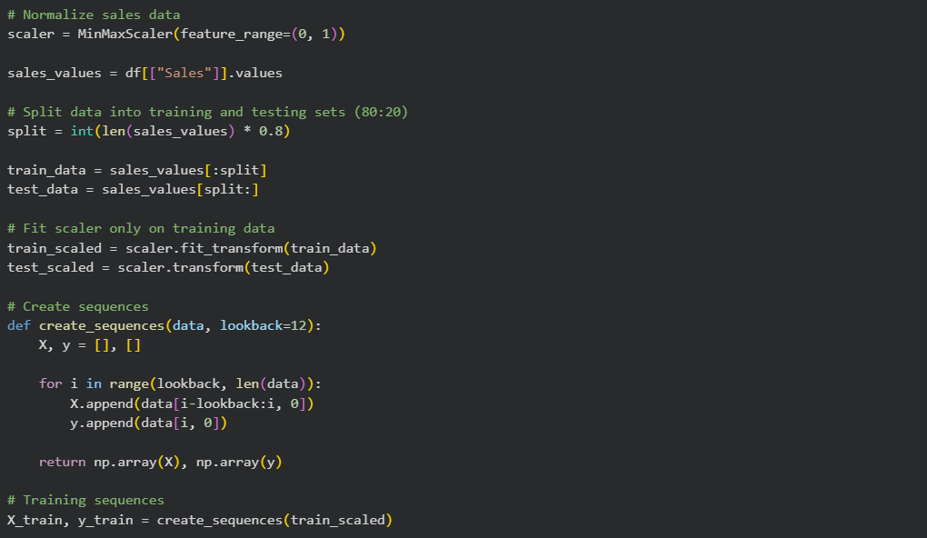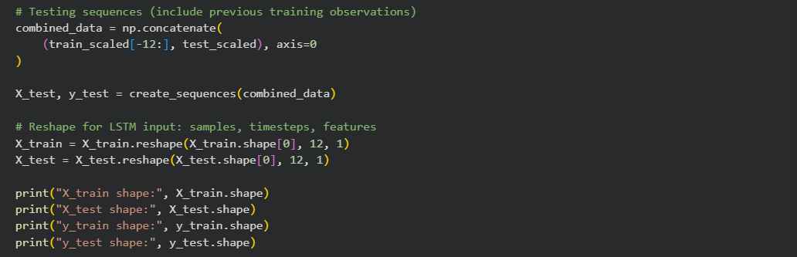
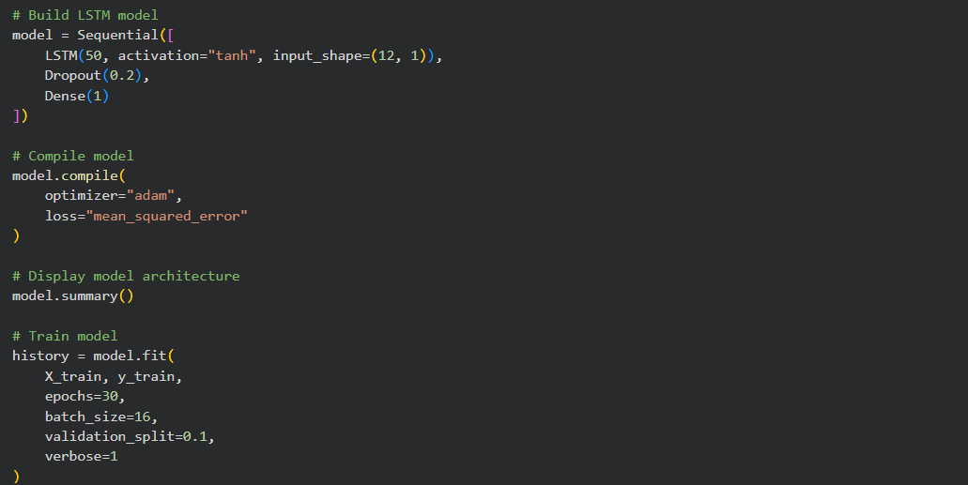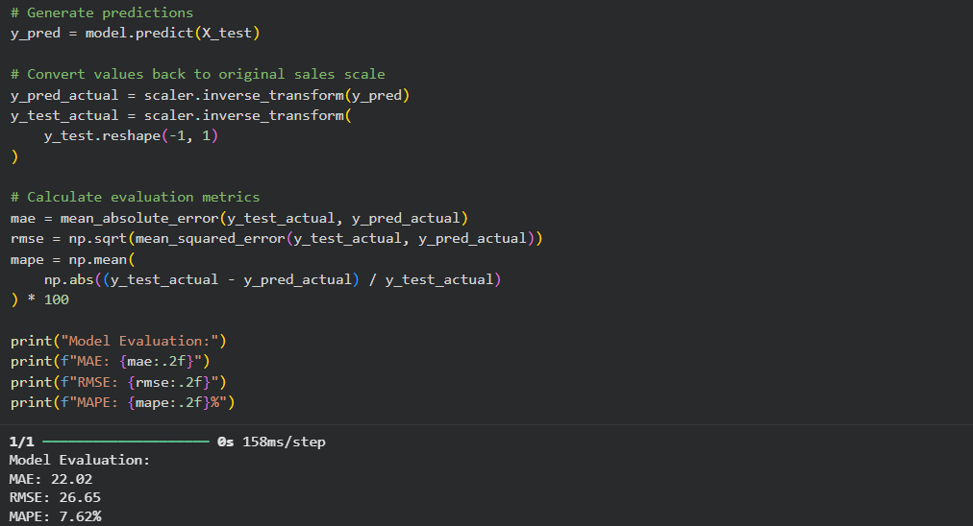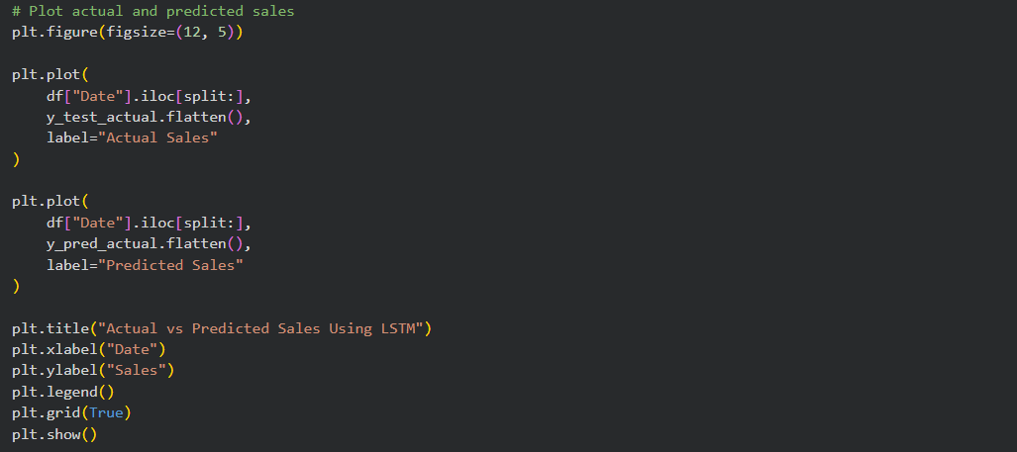
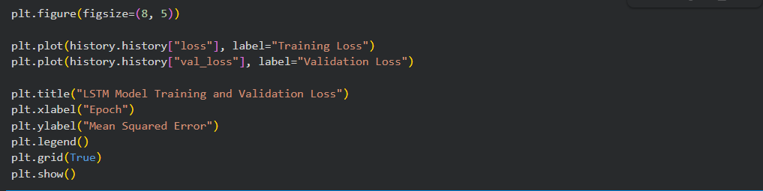
Output :
Figure 1: Actual vs. Predicted Sales Using LSTM
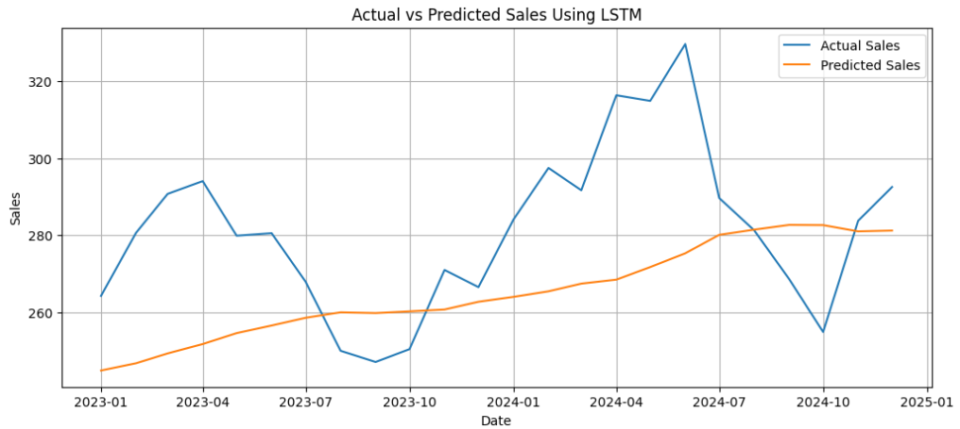
Figure 2: LSTM Model Training and Validation Loss
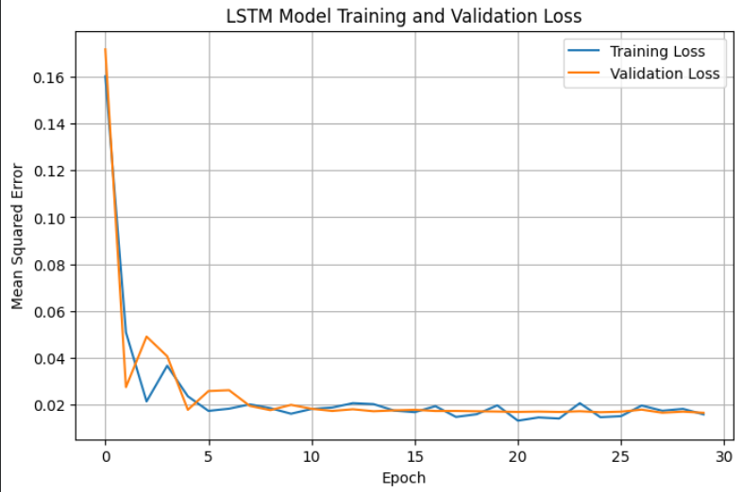
Conclusion : An LSTM-based model was developed for monthly sales forecasting using a synthetically generated dataset. The model was trained using historical sales sequences and evaluated using MAE, RMSE, and MAPE. The actual and predicted sales were visualized to analyze forecasting performance, while training and validation loss were used to monitor the model's learning behavior.

